Final Report

On

**Augmented Reality**

**Bridging Real and Virtual Worlds**

Team Name – ***Reformers***

**Author**

**Anurag Arora**

**Ajay Kumar Garg Engineering College**

**Mob: 8750276175**

[**reachanuragarora@outlook.com**](mailto:reachanuragarora@outlook.com)

**Augmented Reality**

**Bridging Real and Virtual Worlds**

***Abstract-* This paper presents Augmented Reality (AR) as a platform that let people use familiar, everyday objects in ordinary ways. The difference is that these objects also provide a link into a computer network. The paper focuses on various methods through which Augmented Reality can be implemented including its applications and limitations. Besides these, the paper also presents the possible future of Augmented Reality.**

***Keywords* – Augmented Reality (AR), Virtual Reality (VR), Mixed Reality (MR), Pattern Recognition, Head– Mounted Displays, World Fixed Displays and Hand-Held Displays.**

**1. Introduction**

Video games have been entertaining us for nearly 30 years, ever since*Pong* was introduced to arcades in the early 1970s. Computer graphics have become much more sophisticated since then, and game graphics are pushing the barriers of photorealism. Now, researchers and engineers are pulling graphics out of your integrating them into real-world environments. This new technology, called **augmented reality**, blurs the line between what's real and what's computer-generated by enhancing what we see, hear, feel and smell.

*Definition*- Augmented reality (AR) is an emerging form of experience in which the real world (RW) is enhanced by computer-generated content which is tied to specific locations and/or activities. In simple terms, AR allows digital content to be seamlessly overlaid and mixed into our perceptions of the real world. In addition to the 2D and 3D objects which many may expect, digital assets such as audio and video files, textual information can be incorporated into users’ perceptions of the real world.

On the spectrum between virtual reality, which creates immersive, computer-generated environments, and the real world, augmented reality is closer to the real world. Augmented reality adds graphics, sounds, haptic feedback and smell to the natural world as it exists. Both video games and cell phones are driving the development of augmented reality. Everyone from tourists, to soldiers, to someone looking for the closest subway stop can now benefit from the ability to place computer-generated graphics in their field of vision.

At least six classes of potential AR applications have been explored - medical visualization, maintenance and repair, annotation, robot path planning, entertainment, and military aircraft navigation and targeting. Despite various concerns, imagine the possibilities: you may learn things about the city you've lived in for years just by pointing your AR-enabled phone at a nearby park or building.

The future of augmented reality is clearly bright, even as it already has found its way into our cell phones and video game systems. The upcoming sections depicts the same.

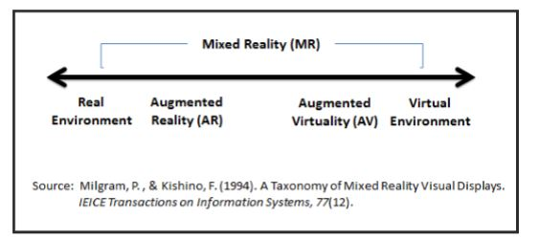

**2. Augmented Reality and Virtual Reality**

Augmented reality (AR) is closely tied to Virtual reality (VR), since the concept of AR evolved as an extension, or variation, of VR (Milgram, Takemura, Utsumi, & Kishino, 1994).

AR is closer to the real world on one end of the gamut with the dominate perception being the real world which is improved by digital data or assets. AV is closer to a complete immersive virtual environment involving systems that are mostly computer generated, but have some real world imagery added. Virtual environments (VE) are environments that are totally simulated by technology. As technologies continues to rapidly advance, it seems possible that the virtual elements and real world elements sharing space in mixed reality environments will become more and more difficult to tell apart. AR is quite similar to virtual reality (VR). Both are interactive, immersive, and include information sensitivity. In VR, users’ frame of reference is completely tied to a virtual world, whereas in AR users’ perception is still centred within the real world, but with virtual objects superimposed, such that real and virtual objects seem to coexist in the same space (Azuma, 1997). Second Life, by Linden Lab, is probably the best known example of VR.

On the other hand, popular gaming consoles such as the Nintendo Wii, the PlayStation 3, and the Xbox 360, have all released sport-centred games, and other games, where the players’ real-world movements control a virtual avatar within a virtual environment. Collectively, these are probably the best known examples of AV. Moving along in the RV Continuum, smart phone apps that utilize GPS data, or which dis- play virtual images tied to real world locations are probably the best known examples of AR. Additionally, the gaming industry is beginning to release AR titles (e.g., Eye of Judgment and Eye Pet, by PlayStation).

**3.** **How to** **Augment Reality**?

**3.1 Augment User** - The user wears or carries a device, usually on the head or hands, to obtain information about physical object.

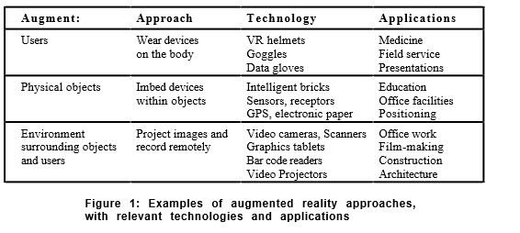

Beginning with the earliest head-mounted display by *Sutherland*, researchers have developed a variety of devices for users to wear, letting them see, hear and touch artificially-created objects and become immersed in virtual computer environments that range from sophisticated flight simulators to highly imaginative games. Some augmented reality researchers have borrowed this "virtual reality" technology in order to augment the user's interactions with the real-world.

**3.2 Augment Physical Object** - The physical object is changed by embedding input, output or computational devices on or within it.

In the early 1970's, Papert created a "floor turtle", actually a small robot that could be controlled by a child with a computer language called Logo. LEGO/Logo is a direct descendant, allowing children to use Logo to control constructions made with LEGO bricks, motors and gears. Electronic bricks contain simple electronic devices such as sensors (light, sound, touch and proximity), logic devices (and-gates, flip-flops, timers) and action bricks (motors, lights). A child can add a sound sensor to the motor drive of a toy car and use a flip-flop brick to make the car alternately start or stop at any loud noise. Children (and their teachers) have created a variety of whimsical and useful constructions, ranging from an "alarm clock bed" that detects the light in the morning and rattles a toy bed to a "smart" cage that tracks the behaviour of the hamster inside.

**3.3 Augment Environment** **–** Neither the user nor the object is affected directly. Instead, independent devices provide and collect information from the surrounding environment, displaying information onto objects and capturing information about the user's interactions with them.

It enhances physical environments to support various human activities. In Krueger's Video Place, a computer-controlled animated character moved around a wall-sized screen in response to a person's movements in front of the screen. Another early example was Bolt's "Put That There" in which a person sits in a chair, points at objects that appear on a wall-sized screen and speaks commands that move computer-generated objects to specified locations.

**4. Implementation Method**

Augmented Reality systems are typically implemented in one of three ways:  head-mounted displays, world-fixed displays, and hand-held displays.

* 1. **Head Mounted Displays**

Position and orientation tracking of the head is essential for head-mounted displays because the display/headphones move with the head.  For a virtual object to appear stable in space, the display must be appropriately updated as a function of the current pose of the head–for example as the user rotates his head to the left, the computer-generated image on the display should move to the right so that the image of the virtual objects appear stable in space, just as they would appear for real world objects.  Well implemented head-mounted displays typically provide the greatest amount of immersion.  However doing this well consists of many challenges such as accurate tracking, low latency, and careful calibration. ***Google Glass*** is a well-known example.

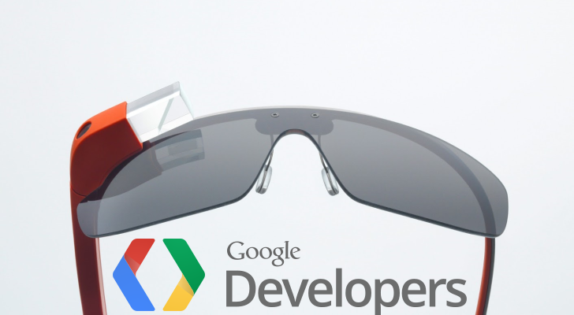

* 1. **World – Fixed Displays**

World-fixed displays render graphics/audio via surfaces/speakers that do not move with the head. Displays take many forms, ranging from a standard monitor (also known as fish-tank VR) to displays that completely surround the user (e.g., CAVEs).  Display surfaces are typically flat surfaces, although more complex shapes can be used if those shapes are well defined or known.  Head tracking is important for world-fixed displays, but accuracy and latency requirements are typically not as is critical as they are for head-mounted displays.

World-fixed displays typically fall between augmented reality and virtual reality.  Often the intent is for the only real-world cue to be visible is the user himself.

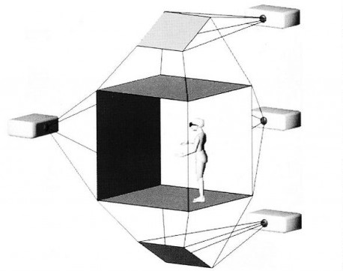

* 1. **Hand-Held Displays**

Hand-held displays are tracked devices that can be held with the hand(s) and do not require precise alignment with the eyes (in fact the head is rarely tracked for hand-held displays).  Hand-held augmented reality, also called indirect augmented reality, has recently become popular due to the ease of access to smartphones and tablets.  In addition, system requirements are much less since viewing is indirect–rendering is independent of the user’s head/eyes.

**5. Technologies Involved**

Augmented Reality technology with mobile is drawing a lot of attention these days by using specialized software’s, users can turn their iPhone, Android or other smart phones into a virtual heads up display.

All the user has to do is to point his phone’s camera at any point/location/building and the relevant information is displayed on the phone’s screen as graphics. Most of the developers of mobile AR applications are expecting AR to become the next “*Big Thing*” in the market.

AR apps like World Surfer (for smartphones like the iPhone and high end Android-Based devices) provided by GeoVector and Mobilizy’s Wikitude World Browse, provide users with a better way to interact with different places in their surroundings.

**5.1 How does an AR app work ?**

a . AR apps need the GPS data to find the current location.

b. The app then governs the phone’s positioning from its electronic compass to detect the direction it is pointing from the current location.

c. The app then looks into database for Text, Hyperlinks, Pictures etc. that have been tagged to that locatinon.

d. If it finds anything relevant then it positions them over the image of the object on the phone’s screen. For example, if it is a resturant, the app displays it’s operating time, menus, directions etc.

e. The AR app usually first displays the required nearest place towards the pointed, follower by other places that are distant.

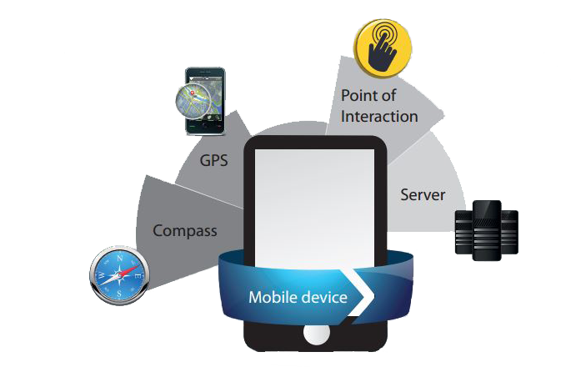

**6. Limitations of Augmented Reality**

Augmented reality still has some challenges to overcome. For example, GPS is only accurate to within 30 feet (9 meters) and doesn't work as well indoors, although improved image recognition technology may be able to help.

People may not want to rely on their cell phones, which have small screens on which to superimpose information. For that reason, wearable devices like Sixth Sense or augmented-reality capable contact lenses and glasses will provide users with more convenient, expansive views of the world around them. In the near future, you may be able to play a real-time strategy game on your computer, or you can invite a friend over, put on your AR glasses, and play on the table top in front of you.

There is such a thing as too much information. Just as the "Crack Berry" phenomenon and Internet addiction are concerns, an overreliance on augmented reality could mean that people are missing out on what's right in front of them. Some people may prefer to use their AR iPhone applications rather than an experienced tour guide, even though a tour guide may be able to offer a level of interaction, an experience and a personal touch unavailable in a computer program. And there are times when a real plaque on a building is preferable to a virtual one, which would be accessible only by people with certain technologies.

There are also privacy concerns. Image-recognition software coupled with AR will, quite soon, allow us to point our phones at people, even strangers, and instantly see information from their Facebook, Twitter, and Amazon, LinkedIn or other online profiles. With most of these services people willingly put information about themselves online, but it may be an unwelcome shock to meet someone, only to have him instantly know so much about your life and background.

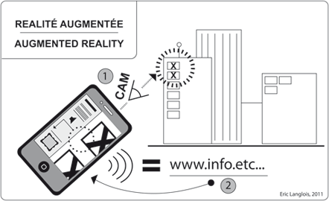

**7. Applications of Augmented Reality**

AR represents the cutting edge of modern society social-technological development. AR applications are being created by inde- pendent groups and organizations all over the world for use within many disparate fields. With this being the case, despite the definitions mentioned earlier in this paper, there remains no consensus as to what constitutes true AR applications and technologies, or how the possible applications of AR should be conceptually organized. According to Azuma et al. (2001), the goal of AR is to use 3D virtual objects as tools to enhance users’ perception of, and in- teraction with, the real world, by causing 3D virtual objects to appear seamlessly within the 3D environment of the real world. However, AR technologies can be designed to interact through many sensory channels (e.g. auditory, visual, olfactory, and haptic) which renders definitions focused only on visual data insuf- ficient to deal with future developments in AR (Hughes, Stapleton, Hughes, & Smith, 2005).

**7.1 Advertising and Marketing**

In no other field has the AR excitement ex- ploded in such a huge way than in advertising and marketing. Companies seeking new ways to engage and interest potential customers have implemented a variety of AR applications which present users with virtual objects, apparently sharing their space, which can be explored and manipulated using natural movements and hand-gestures. For example, cutting-edge automotive campaigns are displaying full-size AR virtual cars in shopping centers and other public areas. A markerless interface allows pedestrians, who do not need AR gloves or other controllers, to use their real-time spatial output (movements) to toggle virtual buttons, open doors, fold seats, and rotate virtual model vehicles.

Smaller products, such as toys, can now be viewed virtually in stores and kiosks world- wide, sometimes with integrated 3D anima- tions. Somewhat more sophisticated campaigns allow users to use their smartphones to view, rotate, and resize virtual models of products, such as furniture, anywhere in their environment, so that they can gain a more accurate impression of how the item would complement their current furnishings and decorating scheme.



**7.2 Medical**

AR technology will not only be able to enhance medical surgical and clinical procedures by improving cost effectiveness, safety, and efficiency, medical AR systems may also assist in the invention of new surgical procedures. AR systems have potential to support surgeons with navigation and orientation before, during, and after surgery.

Medical AR applications will allow for more advanced pre-operative imaging studies, letting doctors and surgeons examine a holographic view of patients’ internal anatomy compiled from CT, MRI, and ultrasound data. After a surgical procedure has been planned, AR systems can use streaming input data to create virtual superimposed images in real- time.

**7.3 Military**

A well-known military AR application in- volves the HMDs, worn by fighter and helicopter pilots, which allow users to view relevant information such as instructions, maps, and enemy locations (Sisodiaa et al. May, 2007). This information can also be displayed on a vehicle screen, or even on the windshield of a cockpit. For soldiers on the ground, as well as in the air, military-grade AR helmets are in development, to be equipped with computers, 360-degree cameras, UV and infrared sensors, stereo- scopic cameras, and OLED translucent display goggles. Wearing AR helmets, soldiers will be able to communicate with a massive “home base” server that collects and renders 3D information onto the wearers’ goggles in real time. Various objects and people will be outlined in specific colors to warn soldiers of friendly forces, potential danger spots, impending air-raid locations, rendezvous points, and other critical data.

**7.4 Travel**

Travel even for non-combatants, AR can be used to enhance users’ experience navigating in the real-world. Civilians are already accustomed to using onboard GPS systems while driving, and to using online search apps to find locations and services they are looking for. Additionally, civilians are growing used to social media, which uses data about people’s real-time, real-world locations to drive interaction and interest in activities. With AR, these services will become visible, as virtual holo-graphic signs, markers, guiding lines, floating arrows, and other cues.

Beyond the simple sensory expansion of these existing services, AR can lead to newer, more comprehensive interfaces showing users tourist (social-historical) and business (locations, services) information relevant to the area surrounding their real-world location, simply by checking with the user’s smart-phone GPS or whenever queried.

**8. Discussions and Future Work**

People were waiting for these moments. When AR (Augmented Reality) would show true value in the marketplace and move beyond some cute digital animation against a physical Starbucks cup and into something of very real value. In the last several weeks alone, a few fantastic examples of where Augmented Reality is really heading have shown up and the good news is, AR has finally gone niche.

As an extreme example, an article recently published by MIT showcases an Augmented Reality helmet designed for, ready for this, welding. And not just any kind of welding, but rather Tungsten gas welding that causes significant challenges to preciseness due to the amazingly bright and incredibly dark, darks created during the welding process with this specific element. Pretty remarkable and amazingly niche.

In a slightly less super-niche way but certainly more commercially mainstream, NConnex, through a nifty augmented reality iPad application, allows you to visualize how a new piece of furniture will exactly fit into your actual living room. Here is a neat video showcasing the technology and the unique way they are also utilizing Microsoft’s Kinect platform to easily generate a 3D model of any piece of furniture.

*3D Printing*, also known as Additive Manufacturing, is a very exciting frontier. Much like Augmented Reality, the possibilities of 3D Printing are really starting to shine as creative ways to use this on-demand manufacturing process are beginning to impact human lives in very big ways. Whether Augmented Reality, 3D Printing or these remarkable programmable pebbles, the future of on-demand creation and manufacturing is quite bright. And even though all three either blend the digital/physical realm, or exist solely in the physical world, it’s important to realize it will be the software and algorithms on the digital side of the equation that will ultimately bring all of this value creation to life.

**9. References**

**[1]** Wikipedia – Augmented Reality

http://en.wikipedia.org/wiki/Augmented_reality

**[2]** How-Stuff-Woks

http://www.howstuffworks.com/augmented-reality.htm

**[3]** Top Coder

https://www.topcoder.com/blog/augmented-reality-goes-niche-3d-printing-gets-real-and-the-future-of-creation-gets-granular/

**[4]** Academia.edu

http://www.academia.edu/

**[6]** Article

http://www.columbia.edu/cu/gsapp/BT/RESEARCH/PAPERS/ar-asce.html